Texture Rub
Lay the paper down and rub your crayon across the paper on three different surfaces. (one surface for each couch)
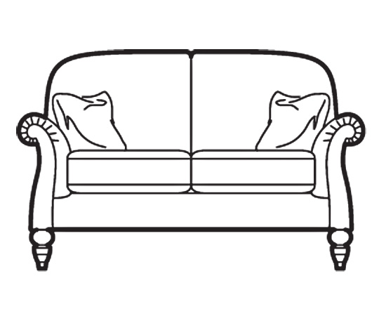
Then cut them out and glue in notebook on the left of texture notes.

