Proportion is: _____________________________
____________________________________________________________________________________________________________________________________________________________________________________________________________________________________
_________________________________________________________

Golden mean: _________________________________________________

_____________________________________________________________________________________
_____________________________________________________________________________________________________________________________________________

Scale is:
_____________________________________________________________________________________________________________________________________________________________________________________________________________________________________________________________________________________________
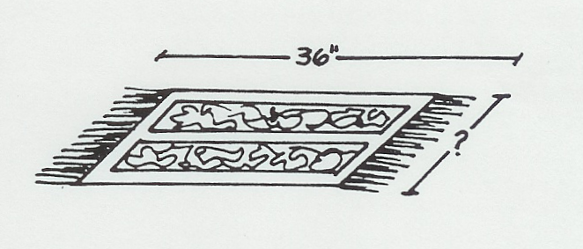
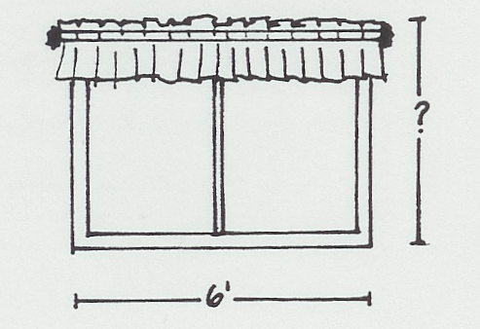
Computing scale:
1 2.

What are the missing measurements?

Proportion is: _____________________________
____________________________________________________________________________________________________________________________________________________________________________________________________________________________________
_________________________________________________________

Golden mean: _________________________________________________

_____________________________________________________________________________________
_____________________________________________________________________________________________________________________________________________

Scale is:
_____________________________________________________________________________________________________________________________________________________________________________________________________________________________________________________________________________________________
Computing scale:
1 2.

What are the missing measurements?

