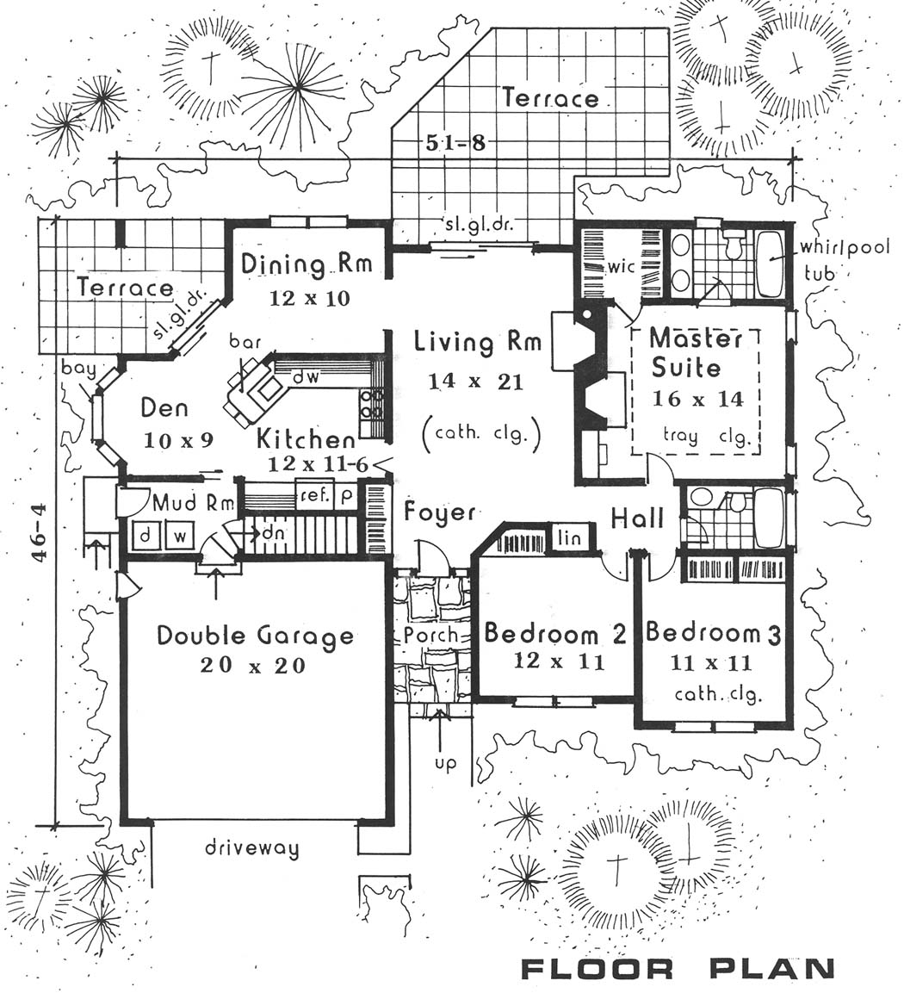

Name :________________________Period:_______________________

Color all the Living/social areas in **YELLOW**

Color all the Sleeping/Private areas in **RED**

Color all the Work/Service areas in **BLUE**

1. Identify the function in each zone in the house?

Living/social:

Sleeping/Private:

Work/Service:

1. Comment on the traffic pattern/circulation paths by listing 2 advantages of the traffic pattern:
2. Comment on 1 like of the house plan:
3. Comment on 1 dislike of the house plan:
4. Is this floor plan an open or closed plan:

Evaluate Main Areas and

Circulation Patterns