Kitchen floor plan foldable: Cut out the hexagon then cut out the boxes on the second page cut on the dotted lines. There is a space for the tab that is glued to the back of each side of the hexagon. Next glue each of the tabs to the hexagon with the floor plan down (so you can’t see the floor plan). Then fold the square shapes in to the center of the hexagon (so that the floor plan can be seen).

Work Triangle

Dimensions: _________________

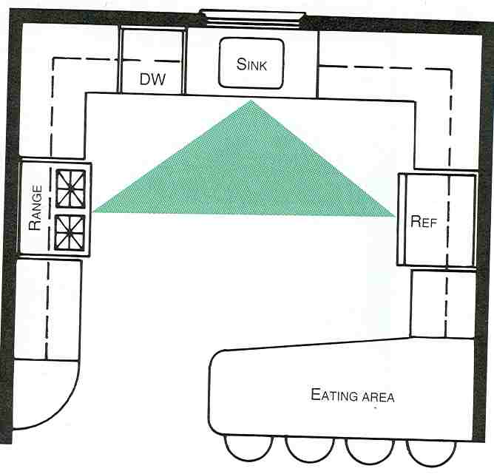
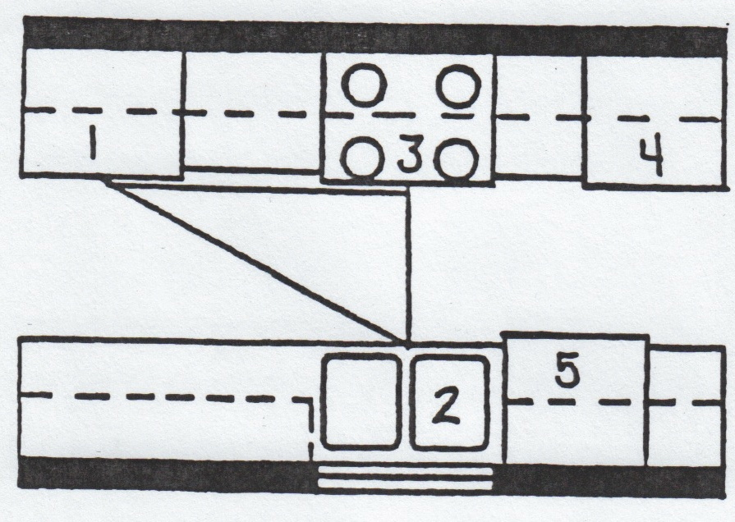

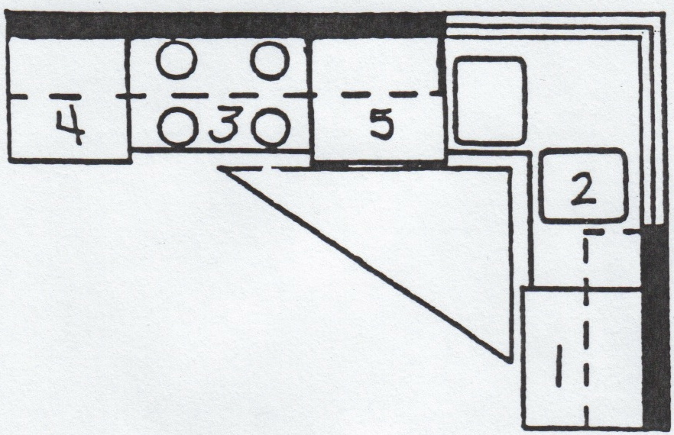

Glue glue

glue glue

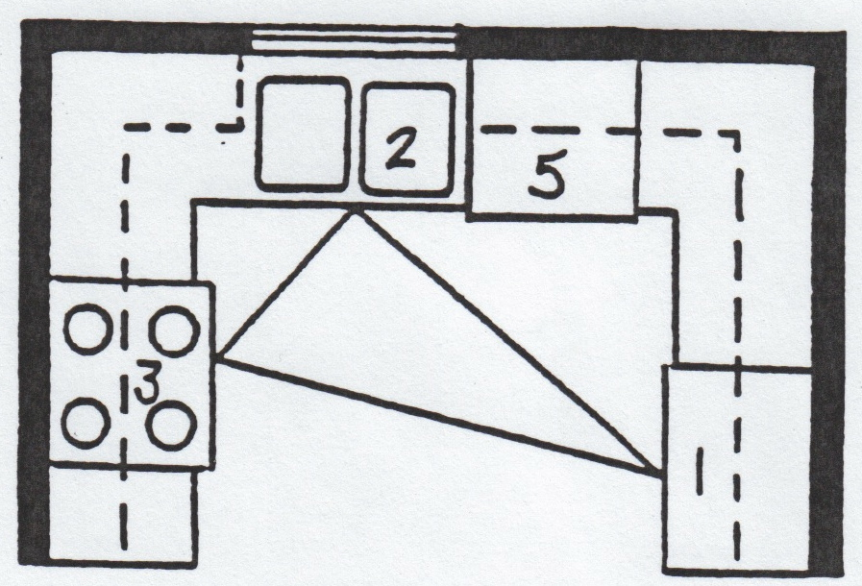

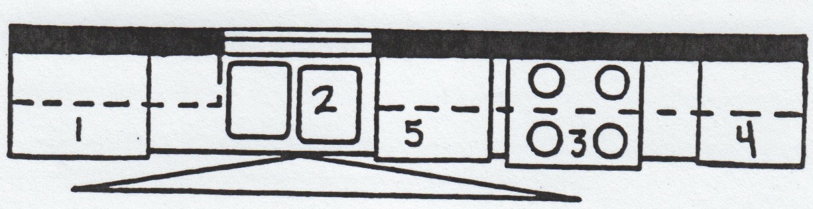
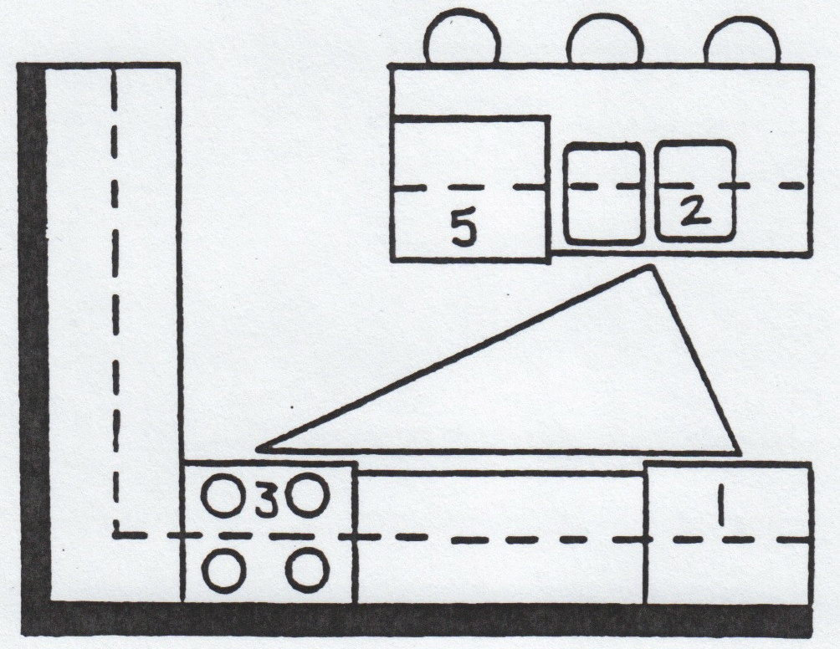

glue glue

