Name: ____________________________
Unit 6

Vitamins, Minerals,
Fruits and Vegetables
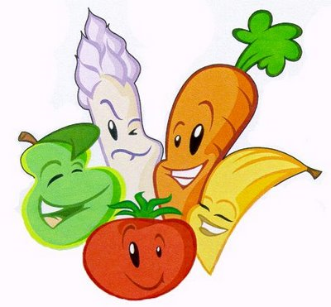

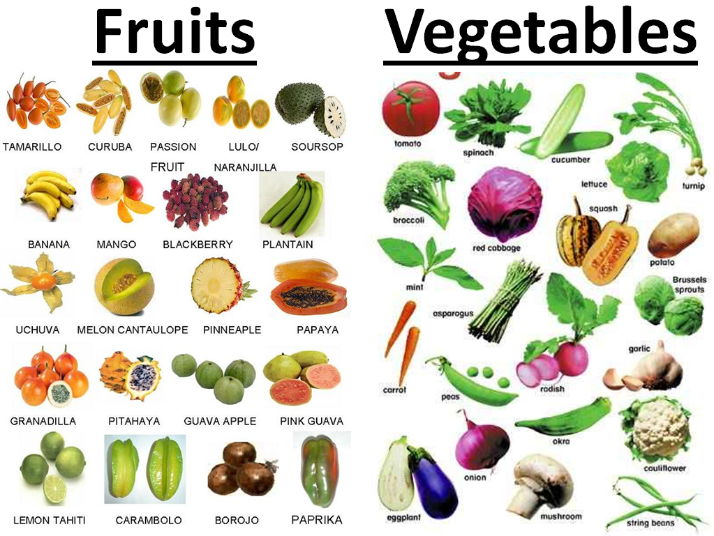
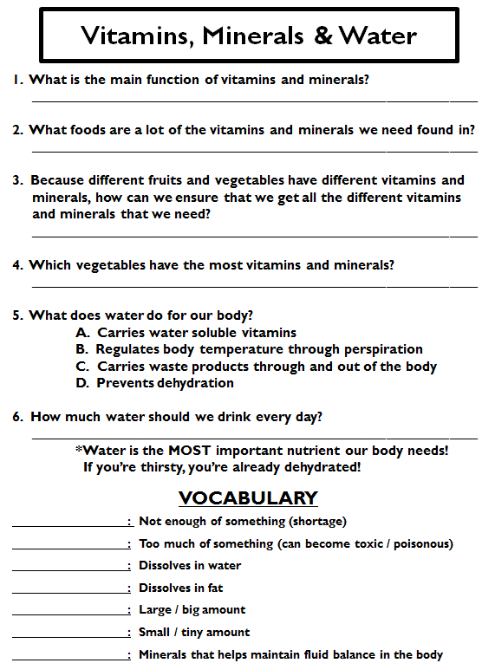
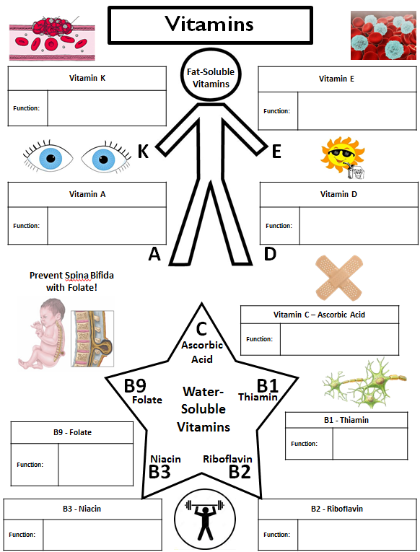
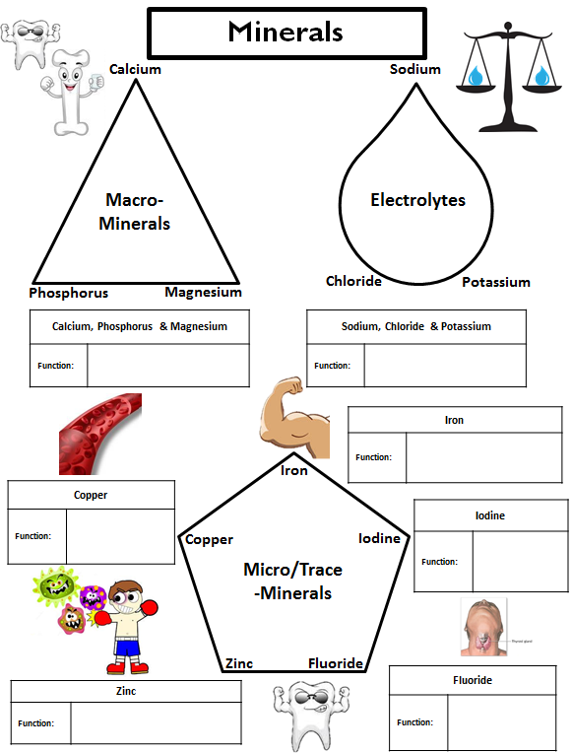
Fruits and Vegetables

FRUITS
Nutrition
- Fruits are 75 – 95% water
- Low in _______, _________ and _____________
- Excellent source of _________ (especially the skins!)
- Vitamins/Minerals Fruits Provide:
  - Vitamin C
  - Vitamin A
  - Potassium
- Choose ____________ or ______________ fruits more often than fruit juice.
- __________, ________ and ___________ can destroy nutrients in both fruits and vegetables.
- Always _______ fruits and vegetables to remove pesticides that might remain on the skin.

Guidelines for Selection Fruits
- Firm • Crisp
- Free from Decay • Smooth
- Dense • Good Color
- Free From Bruises • Good Smell
- In Season (Will Be Cheaper)

Purchasing and Storing Fruits
- Store Fruits in:
  - _______________________
  - _______________________
  - _______________________

Ripening
- ___________ happens when ______________ found in the fruit break-down into __________
- This leads to deterioration or spoilage:
  - Color Lightens
  - Texture Softens
  - Decreases in Acidity
  - Increases in Sweetness

Browning
- ____________________ occurs when the cut surfaces of food reacts with oxygen.
- This is called __________________.
- To prevent this, cover cut fruits with a liquid containing _____________________________

VEGETABLES
Nutrition
- Vegetables provide the following vitamins and minerals:
  - Vitamin A
  - Vitamin C
  - Vitamin D
  - Potassium
  - Folic Acid
  - Calcium
  - Magnesium
  - Vegetables contain NO ___________________
  - They are low in _____________, ________ and _____________ (They are “______________ ________________”)
  - Eat more ___________, ______________ and _________________________ vegetables form the vegetable group.

Best Cooking Methods for Preserving Nutrients
- The two BEST methods are:
  - ___________________________
  - ___________________________
- You can also:
  - Bake
  - Stir-Fry
  - Simmer
  - Sauté

Five Ways to Preserve Nutrients When Cooking Fruits and Vegetables
- Cook in __________________ pieces
- Use ___________ amounts of ____________
- Cook only until ________________________
- Cook ________________________
- _____________________________ used to cook in for soups and gravies (most nutrients dissolve into the water)

