Name: ___________________________

Unit 5
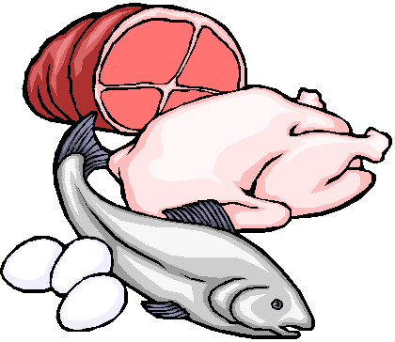
Protein

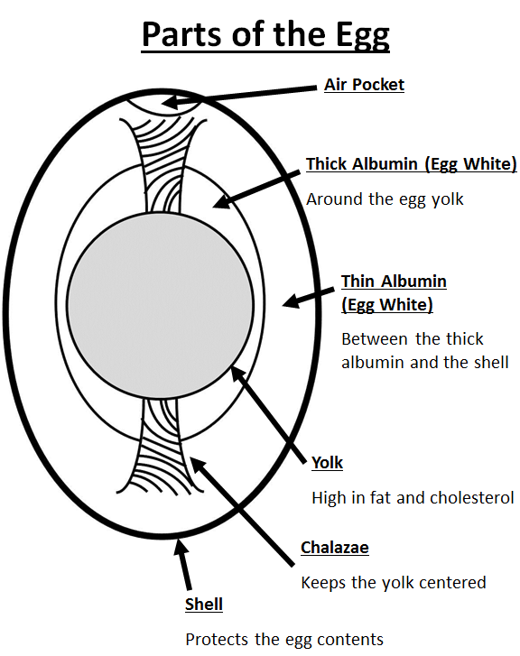
Protein
PROTEIN
- Proteins provide _________ calories per gram.
- The main function of protein is to ___________________________________________________.
  - If carbohydrates and fat are not available, your body will use protein. Is this a good thing? _______
- You must eat protein __________________ to replace the wear and tear on the body tissues.
- We get most of our protein from the ________________________________________.
- It is recommended that we choose _________________________________ products in the place of some meat and poultry every week.
- ________________________ are the “__________________________________” of protein.
- There are ________________ essential amino acids.
- _________________________________ means that your body MUST have them.
- _________________________________ contain all 9 of the essential amino acids.
- Complete proteins com from ________________________ sources.
- _____________________ (from soybeans) is the only complete protein from a plant source.
- ___________________________________________ do NOT contain all of the essential amino acids.
- Incomplete proteins come from ___________________________ food sources.
- Examples of incomplete proteins could be:
  - GRAINS d. RICE
  - BEANS e. WHEAT
  - NUTS/SEEDS
- Incomplete proteins can be ______________ to create a __________________________ protein.
- Examples include:
  - BEANS AND RICE
  - PEANUT BUTTER AND WHOLE WHEAT TOAST
  - BEAN SOUP WITH A WHEAT ROLL

EGGS

- Eggs are very porous. They should be __________________ in their ____________________________. The cardboard helps block unwanted odors from seeping into the eggs.
- Eggs have an expiration date printed on the carton. They usually last _________________________.
- Methods of cooking eggs include:
  - HARD COOKED d. FRIED
  - SOFT COOKED e. POACHED
  - SCRAMBLED
- When eggs are cooked, they __________________. This means that the liquid transforms into a solid.
- Eggs perform different jobs in different foods. These include:
  - ________________________ Example: ________________________
  - ________________________ Example: ________________________
  - ________________________ Example: ________________________
  - ________________________ Example: ________________________
  - ________________________ Example: ________________________

MILK

- It is recommended that we _________________________________________________________ and get at least _______________________ daily from the Dairy food group.
- Milk and milk products, (yogurt, cheese, etc.) are excellent sources of ___________________ ________________________because they come from animal sources.
- By law, milk must be fortified with _____________________________________________.
- ______________________________ means that “EXTRA” has been added to the project.
- You can also get Vitamin D from ________________________. That is why it is sometimes called the “_____________________ VITAMIN”.
- Milk products also provide important minerals like CALCIUM, IRON and PHOSPHORUS to help build healthy bones and teeth.
- Milk goes through several treatments before it is safe to drink. Two of these processes are:
  - _________________________________: milk that has been HEAT TREATED to remove or kill harmful organisms.
  - _________________________________: the fat particles in milk have been BROKEN DOWN and evenly distributed so they cannot join together again.
- There are several types of Milk:
Type of Milk | Description
a. WHOLE MILK | Contains the highest amount of fat-(At least 3.25% or more)
b. 2% MILK | Contains only 2% milk-fat
c. 1% MILK | Contains only 1% milk-fat
d. SKIM MILK (FAT-FREE MILK) | Contains no fat
e. NON-FAT DRY MILK | Skim milk that has been dehydrated and packaged
f. EVAPORATED MILK | Milk that has had all water evaporated out of it
g. SWEETENED CONDESNSED MILK | Milk with sugar added and then had water evaporated out
h. UHT MILK (Ultra High Temperature) | Milk heated to 280° for 2 seconds to kill bacteria
i. LACTOSE FREE MILK | Milk that has had the lactose sugar removed
j. BUTTERMILK | Milk with lactic acid added
k. ACIDOPHILUS MILK | Special milk to help those with digestive disorders
l. FLAVORED MILK | Milk with flavorings added (chocolate, strawberry, etc.)

- Milk products _______________________ easily.
- Scorching occurs when the proteins in milk are _____________________________. They fall and cling to the bottom of the pan. They create a thick, black layer that is difficult to remove.
- To prevent scorching, cook milk on ___________________ and STIR IT ________________________to prevent the proteins from collecting on the bottom of the pan.
- Heating milk in the ________________________ will also prevent scorching.

CHEESE

- There are two types of cheese: _______________________ and ____________________________.
- Natural cheeses include:
Type of Cheese | Examples
a. FRESH (Unripened) | Cream Cheese, Feta, Mozzarella, Ricotta
b. SOFT CHEESES | Brie, Boursin, Camembert
c. SEMI-SOFT CHEESES | Fontina, Gorgonzola, Couda
d. FIRM CHEESES | Cheddar, Gruyere, Provolone
e. HARD CHEESES | Asiago, Parmesan

- Processed cheese is cheese made from natural cheeses, but has had emulsifiers, colorings and PRESERVATIVES added to INCREASE SHELF-LIFE. It is also easier and cheaper to produce.
- Processed cheese include:
Type of Cheese | Examples
a. PROCESSED CHEESE | American Cheese (Cheese Singles), Easy Cheese (Spray Cheese), Velveeta, Powdered Cheese

- To reduce fat intake in the Milk and Dairy Group, you can:
  - ________________________________________________________
  - USE A LOWER FAT CONTENT CHEESE________________
  - SUBSTITUTE YOGURT FOR MAYONNAISE_____________

