Name: ___________________________

Unit 3

Carbohydrates
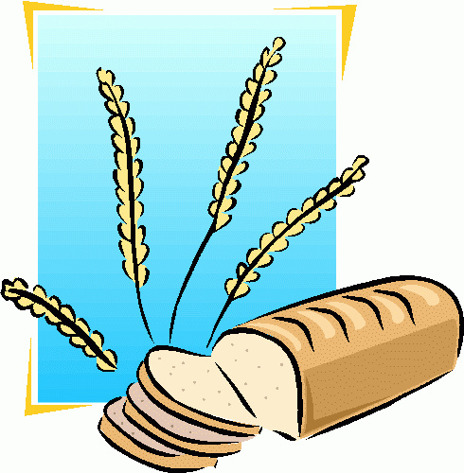

CARBOHYDRATES

1. We get most of our carbohydrates from the __________________ group.
2. ________________ and ____________________ are also a good source of carbohydrates.
3. Almost all of our carbohydrates come from ____________________ food sources.
4. The main function of carbohydrates is to ___________ _________. They provide _____ calories per gram.
5. If we eat more carbs than our bodies need for energy, they get stored as ____________.
6. The three types of carbohydrates are:
a. ____________________________
b. ____________________________
c. ____________________________
7. Sugars are ______________. Starches are __________________.
8. Complex Starches will ______________________ into Simple Sugars.

Draw a Picture of the Following and CIRCLE the Better Energy Source:

SIMPLE SUGAR | COMPLEX STARCH

9. List the different types of sugars and their food sources:

SUGAR | OTHER NAME | FOOD SOURCES
A. | “Blood Sugar” | Fruit, Vegetables, Grains
B. | “Table Sugar” | Table Sugar, Sugar Cane
C. | “Fruit Sugar” | Fruit
D. | “Malt Sugar” | Grains
E. | “Milk Sugar” | Milk

FIBER

1. The average American does not get enough __________________ in their diets.
2. The National Cancer Institute recommends that the average person gets _____________ of fiber every day.
3. Two other common names for fiber are: ________________ or __________________
4. Fiber is important because it attracts _____________ to the _________________ and helps move food through our systems faster. You have to have water along with fiber or it is not as effective.
5. Benefits of fiber include a lowered risk of ____________________, hemorrhoids and colon or rectal cancer.
6. List the two types of fiber and the main functions they perform:

Type of Fiber | Function
A. | Show to lower total blood cholesterol
B. *Will NOT digest or dissolve | Helps move food through the body

7. __________________ is insoluble, or ________________________.
8. Fiber only comes from _________________ food sources. You CANNOT get fiber from animal food sources.
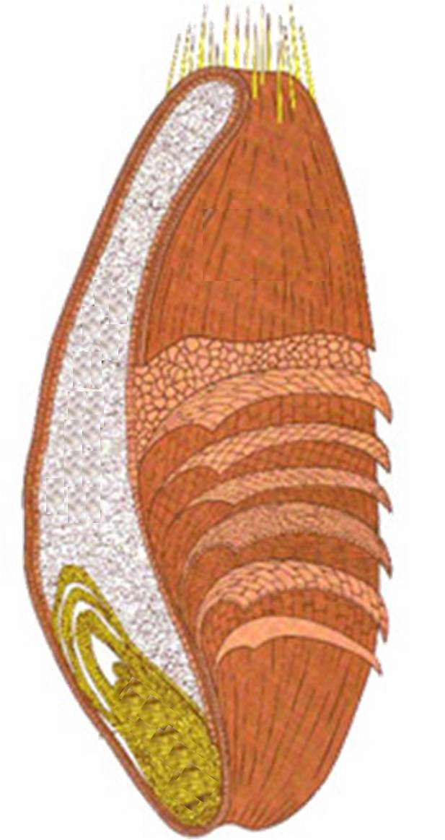
9. Foods that are high in fiber include:
A. ______________
Provides:
Starch
Protein
a. ____________________________________
b. ___whole grains___
c. ___legumes/beans___
d. ___Bran___
B. _______________
Provides:
Unsaturated Fatty Acids
“B” Vitamins
Vitamin E
Iron
Zinc
Other Trace Minerals
10. Ways to increase fiber in the diet include:
a. ___________________________________
b. ___Use whole wheat flour___
c. ___Eat the skins___
11. Label the wheat kernel to the RIGHT:
12. The MOST beneficial part of the wheat kernel is: ______________________
13. The LEAST beneficial part of the wheat kernel is: ______________________
14. When a product claims that is it “Whole Wheat” or “Whole Grain”, it must use the ______________ wheat kernel, or all three parts.
C. _________
Provides:
Fiber
Vitamins
Minerals
15. Other products, like white bread and rice, usually only use the _______________, which is the _____________ beneficial part of the wheat kernel.
16. ___________________: some of the nutrients that were lost in processing are added back into the product
17. ___________________: 10% more of the Daily Value for the nutrient is being added

Yeast Breads

1. What is the purpose of each ingredient in yeast breads?
Ingredient | Function
 | Body/Structure
 | Produces CO2, provides leavening to make light, airy and porous
 | Controls yeast and adds flavor
 | Provides tenderness
 | Dissolves and activates yeast
 | Food for yeast
 | Provides color, texture and nutrients

2. What is proofing?
The period of time when the bread is _______________ and ____________ is being produced.
3. What happens if the liquid you add to the yeast is too hot?

4. What happens if the liquid you add to the yeast is too cold?

5. What affect does salt have on yeast?

6. What is the effect of mixing baking soda with an acid?

7. What are some common acids added to foods to help produce leavening? (List at least 3)

RICE & PASTA
1. List the types of rice below:
Type | Description
A. | Shorter than long grain rice. When cooked, it is moist and tender.
B. | 4-5 times longer than the width. After cooked, it will be light and fluffy.
C. | Short, plump and almost round. Cooked grains are soft and cling together.
D. *Has the most fiber! | Chewy texture and “nut-like” flavor. Rich in vitamins, minerals and fiber.
E. | Long, dark and streaky color. Distinct flavor.
F. | It has been completely cooked and then dehydrated. The process reduces time required for cooking.

2. To cook rice:
A. Use about 2 cups of water for every cup of rice.
B. Bring water to a boil.
C. Add rice and ______________________________.
D. Bring water back up to a boil.
E. Reduce heat so rice will simmer.
F. Check for doneness. The rice should be tender but firm, and there should be no water left.
G. If some water remains, continue cooking, but remove the lid.

3. RICE YIELD:
_______________ uncooked rice will make _______________cooked rice (1:3 ratio)
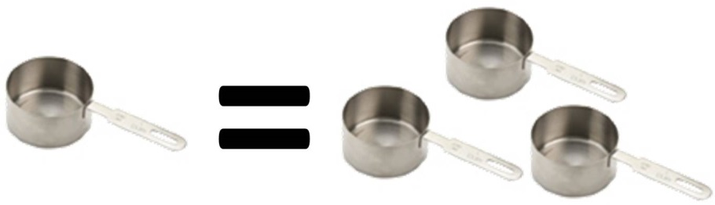

4. To cook pasta:
A. Use about 1 quart of water for every 4 ounces of dry pasta.
B. Bring water to a boil.
C. Add pasta slowly to boiling water so boiling does not stop.
D. _______________________________________.
E. Stir pasta frequently while it’s cooking.
F. Cook pasta to al dente stage (pasta remains firm to the bite).
G. Drain pasta in a colander.
H. To keep pasta warm, set the colander over a pan of hot water and cover the colander.

5. PASTA YIELD:
____________________ uncooked pasta will make ___________________ cooked pasta (1:2 ratio)
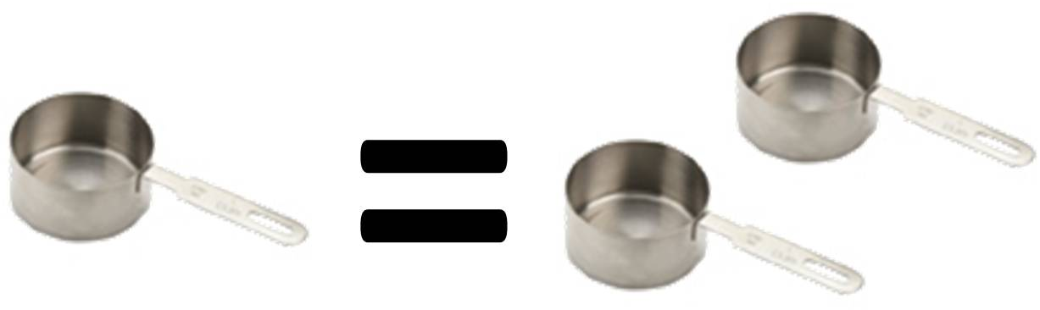

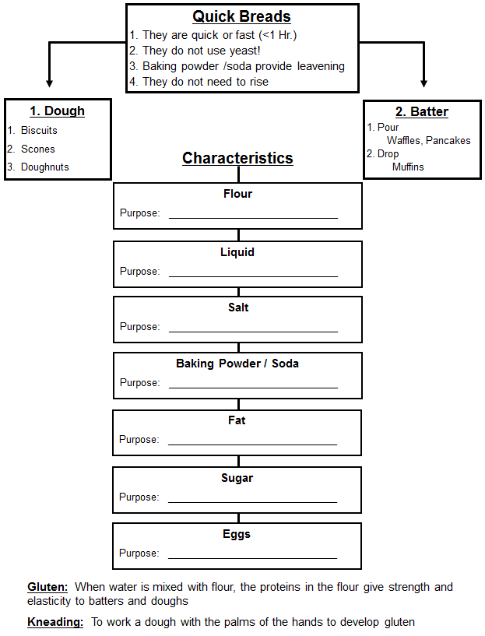
Muffin Method of Mixing

- Combine all dry ingredients together into a bowl.
- In a separate bowl, blend all of the liquid ingredients, (including fat.)
- Make a well in your dry ingredient bowl and pour the liquid in the well.
- Stir until dry ingredients are moistened.

The Perfect Muffin: Drawings:

The Under-Mixed Muffin:

The Over-Mixed Muffin:

Biscuit Method of Mixing

- Combine all dry ingredients.
- Cut-In the fat until there are crumbs.
- Add the liquid and stir until a dough forms.
- Knead the dough so gluten will form.
- Cut into biscuits with biscuit cutter.
- Place on a greased cookie sheet.

What does a perfect biscuit look like? Drawing:

Two of the most important steps in making biscuits are:

