Name: ___________________________

Unit 2

Safety & Sanitation
Plus
Microwave Cooking
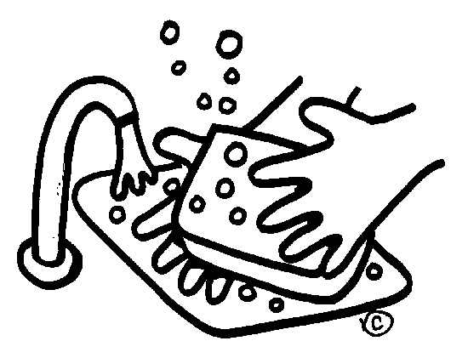

Safety and Sanitation

When working with ELECTRIC APPLIANCES:
- Keep your hands dry.
- Stand on a dry surface.
- Keep electric appliances away from water
- Avoid using metal objects on electric appliances.
- Unless absolutely necessary, avoid using an extension cord.
- Do not ___________________ too many appliances into the same outlet. It could get over-loaded and explode or get overheated and cause a blackout.
- When cleaning appliances make sure they are unplugged.
- If someone is getting shocked by an appliance, first ____________________________________________, then unplug the appliance before approaching the injured person.

To avoid CUTS:
- ___________________ knives are safer than dull ones.
- Do not put knives in a drawer full of knives.
- Store knives in a knife block or a knife rack.
- Clean up any broken glass immediately.
- In the case of someone getting cut, the general rule is to ______________________ by using a clean cloth covering the wound and pressing directly on the wound.
- Sometimes, you will need to apply pressure on the wound and on the nearest ______________________.

To avoid getting BURNED:
- Stand to the side of the oven when opening it.
- Use hot pads for handling hot pans, etc. (This includes those coming out of the microwave.)
- Lift the lids off of foods so the steam goes _____________________________________ and your face.
- Pull the rack of the oven out rather than having to reach in.
- Turn the pan handles toward the ___________________________________ of the stove.
- If it is a __________________ degree burn, it will be red, but there will not be any blisters. In this case, you should _____________________________________________.
- If it is a second degree burn, it will have blisters and be red. In this case you can cover with a cool cloth, or have a doctor check it if it is a large area.
- If it is a third degree burn, the skin will be discolored or melted away. In this instance, you should determine how large of an area is burnt, then call for help. Avoid touching the burnt area and lightly cover the area with a cool cloth.

How to avoid FALLS:
- Use a ___________________ to reach things in high places.
- Clean any ________________ as soon as they happen.
- If there is a fall, assess the injures:
  - Make sure they are breathing.
  - Check for bleeding.
  - Make them comfortable.
  - Remove them from activity path.

To help prevent FIRES:
- Keep all flammable objects away from direct heat.
- Never put paper towels on the range.
- Watch your stove carefully. Never leave it unattended.
- If it is a grease fire:
  - Put a ________________ on it
  - Pour __________________ on it
  - Use a fire __________________________
- Do NOT ever use:
  - _____________________
  - _____________________
  - _____________________

CLEANING and CLEANING SUPPLIES:
- You should keep all surfaces and equipment clean.
- Wash the counter with a disinfectant before you begin to cook.
- _______________________________. It will keep the area clean and will make the clean-up much easier.
- To properly wash dishes:
  - Throw away or rinse any food left on dishes
  - Fill one sink with hot soapy water
  - Fill the other sink with plain hot water
  - Wash dishes in soapy water, then rise all soap away in the plain hot water
  - Place dishes in dish rack or dry with a clean towel
- When you are doing the final clean-up, you should wash the dishes in the following order:
  - _______________________________
  - _______________________________
  - _______________________________
  - _______________________________
  - _______________________________

To prevent POISIONING and CONTAMINATION by cleaning supplies:
- Keep all chemicals away from the food. Store them in a different place than you store your food.
- Keep supplies in their _______________________________________ and make sure they are labeled with their contents, what they are there for, and how to use them.
- The safest rule as far as mixing cleaning supplies is: DO NOT MIX THEM!
- Combinations like ________________ and _____________ will produce a deadly ________________!

Sanitation Rules:
- Always wash hands for a minimum of _______________________.
- Wash your hands:
  - ___________________ Cooking
  - ___________________ Cooking
  - ___________________ Cooking or Handling Raw Meat
- Wear gloves while cooking if you have a cut or open sore on your hands.
- Pull back or cover hair while working in the kitchen.
- Use plastic cutting boards, not wooden ones.
- When tasting foods, use a clean spoon every time.
- Keep foods out of the _____________________________________________________.
- Foods should be stored within two hours.
- Always check the internal temperature of foods with a food thermometer.
- Seafood, beef, veal, lamb and pork should be cooked to at least ____________.
- Ground meats, such as ground beef, should be cooked to at least ___________.
- All poultry should be cooked to at least _____________.
- When reheating food, make sure the internal temperature is at least __________.
- Keep hot foods __________ and cold foods __________.
- When in doubt, ____________________!
- The best ways to ___________frozen food:
  - __________________________________________
  - ___________________________________________
  - ___________________________________________

Food Borne Illness
- What is a food borne illness?
  - An illness caused by eating food contaminated with________________________.

- How common is Food Borne Illness?
  - _______________________ common! There are millions of cases each year.

- What are some general symptoms of Food Borne Illness?
  - Nausea • Headaches • Abdominal Cramps • Fatigue
  - Vomiting • Fever • Diarrhea • Body Aches

- How serious is Food Borne Illness?
  - It can be very mild or potentially __________________________!

- What four things do bacteria need to be able to grow?
  - ________________• ________________• ________________• ______________

- What does a virus need to be able to grow?
  - A ___________________ (something to live and multiply in)

- How are most Food Borne Illnesses spread?
  - When food is left in the _____________________________________ for too long
  - __________________ food handling practices

- How can most food borne illnesses be prevented?
  - Using ______________ food handling practices
  - Keeping food ________________ of the temperature danger zone

- What is the temperature danger zone?
  - ANY temperature BETWEEN ______°F and _________°F

- SALMONELLA
Found In: _______________________________________

- E. COLI
Found In: _______________________________________

- STAPHYLOCOCCUS (STAPH)
Found In: _______________________________________ (Sneezing, Coughing, etc.)

- BOTULISM
Found In: ________________________________________

- HEPATITIS A
Found In: _________________________________________ (usually from improper hand washing after using the restroom)

Based on the information you’ve learned so far, list TEN ways to prevent the spread of a food borne illness:

- _____When in Doubt, Throw it Out!_____________________
- __________________________________________________
- __________________________________________________
- __________________________________________________
- __________________________________________________
- __________________________________________________
- __________________________________________________
- __________________________________________________
- __________________________________________________
10._________________________________________________

Microwave Cooking
1. Microwaves are ATTRACTED to:
a. _______________ b. _______________ c. _____________

2. Microwaves are REPELLED by:
- _____________

3. What materials or containers are microwave safe?
a. _______________ b. _______________ c. _____________

4. What part of the microwave oven generates the microwaves?

5. Which container cooks more evenly-Round or Square? WHY?

6. What is standing time and WHY is it important?
WHAT: The amount of time food is allowed to sit _____________ microwave cooking in order to _____________________________________.
WHY: If you don’t allow for standing time, you will ___________________________.

7. Why should you stir or rotate food when microwave cooking?

8. What part of the microwave will rotate the food while it is cooking?

9. Why is it best to cover most foods when microwave cooking?
- ________________________________________
- ________________________________________
- ________________________________________

10. Why do foods NOT brown in the microwave?

11. How can you prevent burns when microwave cooking?
a. _________________________________________
b. _________________________________________
c. _________________________________________
