Name: ________________________
Class: ___________________

Foods I
Dietary Analysis

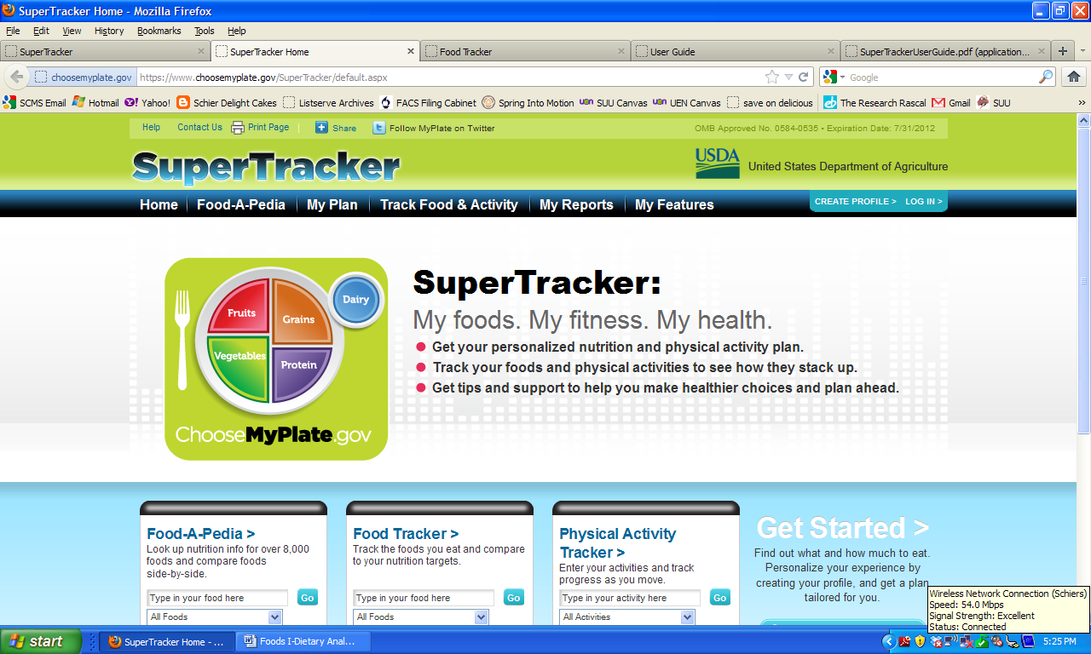
- Go to: https://www.choosemyplate.gov/SuperTracker/foodtracker.aspx
- Click on: on the upper right hand side of the screen.

- Complete the Profile Information section including: Profile Name, Age, Gender, Physical Activity, Height and Weight. You do NOT need to Register to Save Your Profile unless you want to.
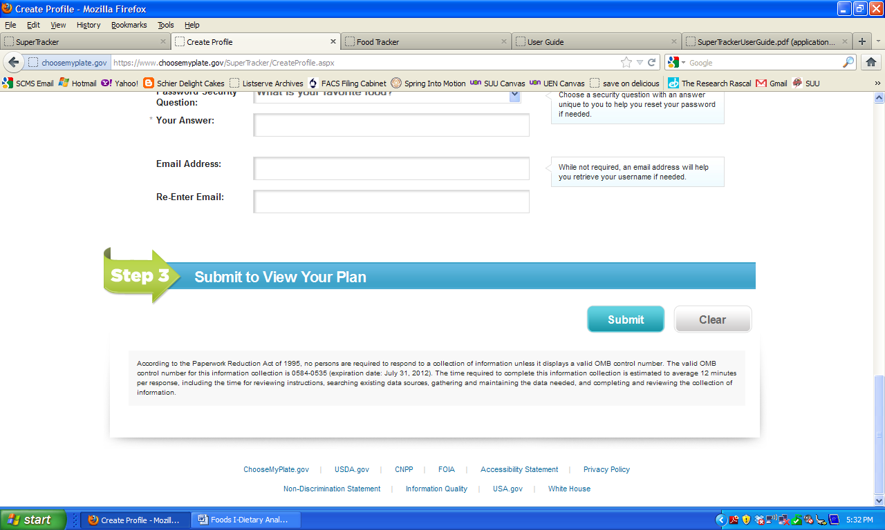
- Click at the bottom of the page.

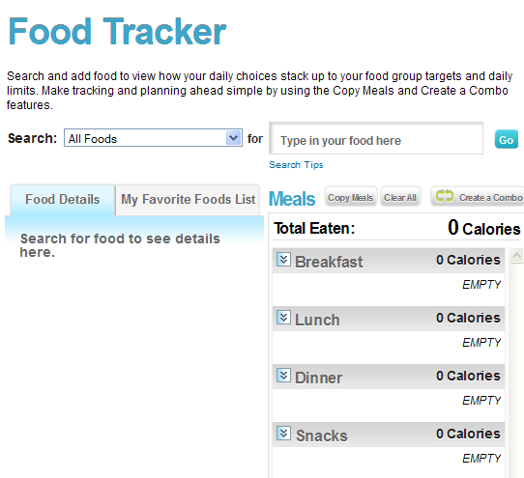
- Using your 2-Day Food Log, begin logging in your daily food intake for Day 1 only.

Be sure to select the correct serving size and indicate if that food item belongs in Breakfast, Lunch, Dinner or Snacks.
(See example Below.)
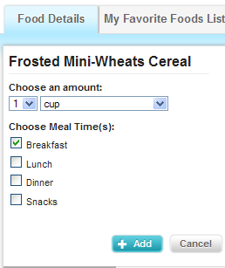

- Enter all foods for Day 1 and fill out the information on the following page.

*When you are finished with the Day 1 Worksheet, select a new day in the upper left hand corner of the screen and input all foods from your Day 2 food list. Then, fill out the worksheet for Day 2.

*Staple your 2-Day Food Log to the back of this packet.

Day 1 Results

1. Fill in the graph below:
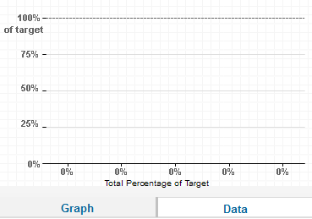
Grains
Vegetables
Fruits
Milk & Yogurt
Protein

2. Fill in the graphs below:
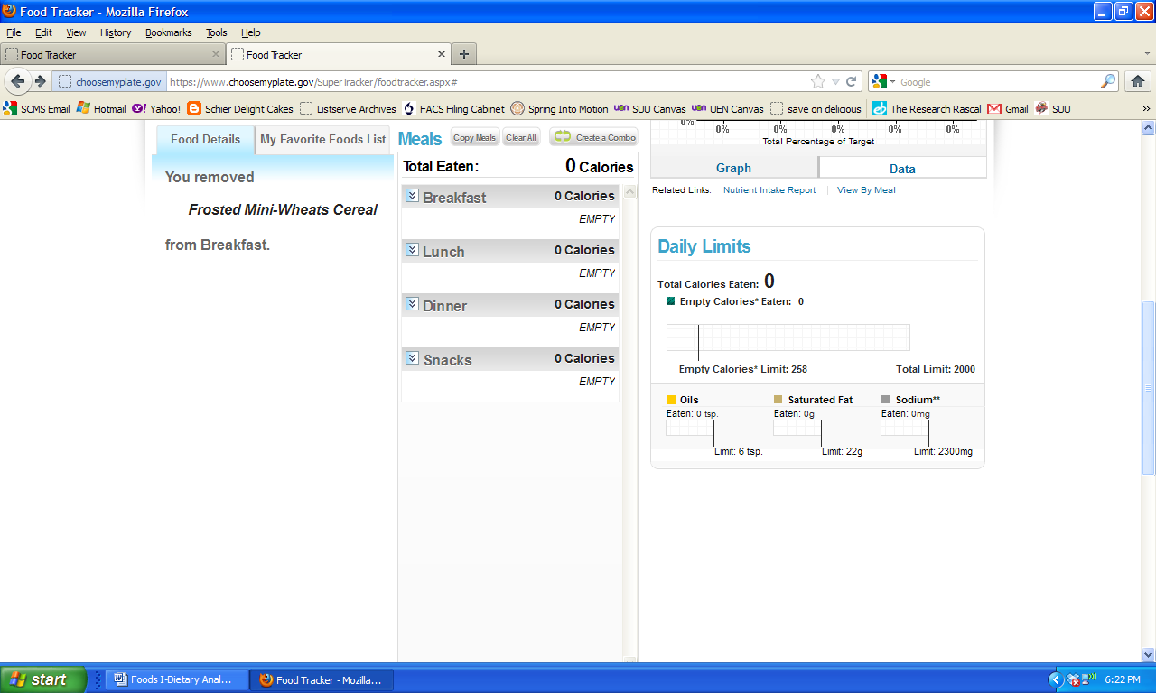

3. Fill in the graph below:

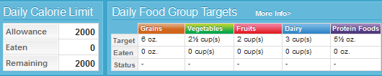
Day 2 Results

1. Fill in the graph below:

Day 2 Results

1. Fill in the graph below:
Grains
Vegetables
Fruits
Milk & Yogurt
Protein

2. Fill in the graphs below:

3. Fill in the graph below:

Day 2 Results

1. Fill in the graph below:

Additional Info

- Go to: http://www.choosemyplate.gov/myplate/index.aspx
- Enter all of your information: Age, Sex, Weight, Height and Physical Activity
- Click SUBMIT at the bottom of the page.
- Fill in the information below based on your results.

Eat these amounts from each food group daily. This plan is a _________ calorie food pattern. It is based on average needs for someone like you. (A ____ year old ______, ___ feet ___ inches tall, ______ pounds, physically active ______________________________ a day.) Your food needs also depend on your rate of growth and other factors. See a health care provider who can track your height and weight over time to identify your specific needs.

tips
tips
tips
tips
tips

Make Half Your Grains Whole
Aim for at least __________ounces of ____________________ a day.

Vary Your Veggies
Aim for this much every week:
Dark Green Vegetables = _________cups weekly
Orange Vegetables = ____________cups weekly
Dry Beans & Peas = _____________cups weekly
Starchy Vegetables = ____________cups weekly
Other Vegetables = _____________cups weekly

Oils & Empty Calories
Aim for ___________________________________a day.
Limit your empty calories (extra fats & sugars) to _________________ Calories.

Write ONE PARAGRAPH describing what you discovered about your personal nutritional needs. What surprised you? What do you know now that you didn’t know before? What are some changes you need to make in your life in order to follow what MyPlate suggests?

