UNIT 5

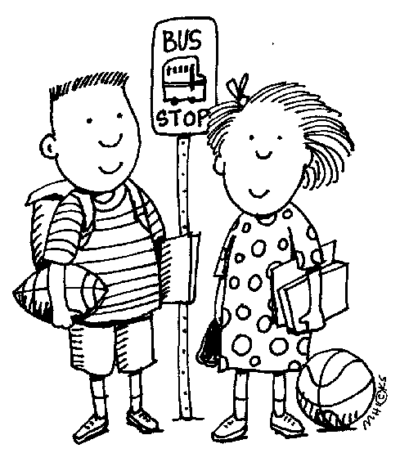
Personal Development

Name: ________________________ Class: _________

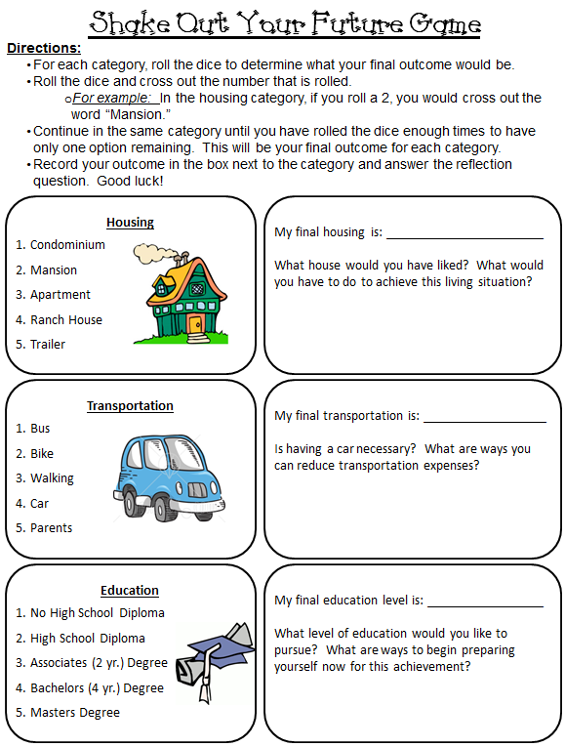
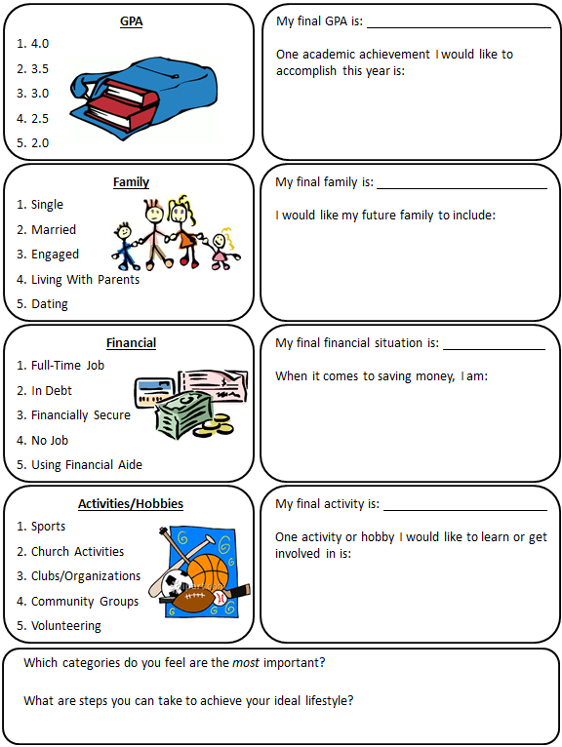
Values and Goals
What are Values?
- Anything that is ______________ _______________, and _____________________
- Influenced by ______________________________________________________, etc.
- Each person has ____________________ values which guide his/her daily decisions

Personal Value Survey
Directions: Think about each item or activity and determine on a scale from 1 to 10 how highly you value each item. (1=the lowest, 10=the highest) Place an “X” in the square for each value.
After ranking the items, circle or highlight the TOP FIVE items you value MOST.
Item/Activity | 1 | 2 | 3 | 4 | 5 | 6 | 7 | 8 | 9 | 10
Being a good friend to others
Be famous
Be a leader
Have a sense of humor
Serve my community
Serve my country
Make a lot of money
Be intelligent
Get married
Be healthy
Be in good shape
Be attractive
Have a pet
Have close relationships
Have nice clothes
Have a nice car
Get a good job
Be independent
Be close to my family
Have a lot of friends
Have a strong religious faith
Do what is morally right
Have children
Work with children or youth
Be a good athlete
Have enough money to feel secure
Communicate well
Be in love
Needs vs. Wants
- ___________: something necessary or required for life
What are examples of needs? _______________________________________________

- ___________: something unnecessary, but desired
What are examples of needs? _______________________________________________

What is a Goal?
- ___________: something a person intends to accomplish

Why Set Goals?
Setting Goals are like a road map:
- They provided _________________________
- They help you focus on the _________________________ things
- They help you keep the ________________________ in mind

Types of Goals
- __________________: can be accomplished within one year (days, weeks, months)
- __________________: Can be accomplished in more than one year

SMART Goals
In order to set goals effectively, they need to be well written, or SMART!
A. __________________: State exactly what is to be done
B. __________________: Include how the goal can be measured
C. __________________: Determine steps to reach the goal
D. __________________: Do not set goals for something unrealistic
E. __________________: State when the goal will be met

SMART Goal Challenge!
Task: Create a free standing tower using your supplies. The tallest tower wins! But…before you build, work as a team and write down a SMART GOAL to serve as your road map!

MARSHMALLOW TOWER SMART GOAL

_______________________________________________________________________________________________________________________________________________________________________________________________________________________________________

Non-Verbal Communication Experiment

Today, you are going to be part of a very important experiment. In order for this experiment to work, you must not talk or vocalize in any way! We are going to communicate strictly by nonverbal means today. Please do your part to make sure this experiment is successful. If you cannot handle this experiment, you will be asked to wait in the hall for the remainder of the class period. Be sure to pay attention to your teacher for other non-verbal instructions.

Instructions:
Throughout this class period, you will be asked to express your feelings non-verbally. Use this worksheet to write down all of your answers and reactions to the activities during the day. Be sure to read through all instructions carefully.

Activity 1
“Object Language” is one type of non-verbal communication. It is the intentional or unintentional display of material things. It might be a work of art, machines, clothing, jewelry, etc. A social worker who appears in a poor, run-down neighborhood driving a flashy car and wearing expensive clothing is obviously using the wrong language if they hope to establish a good rapport with the people they are trying to help. On the bottom of this paper, list FIVE objects in this room and describe the message you receive from each of them. (The objects may be part of someone’s attire, but remember, describe the object, not the person.)

Description of Five Objects
OBJECT | DESCRIPTION
1.
2.
3.
4.
5.

Activity 2
Watch the video clips that will be played on the screen for about 10-15 minutes. There will be no sound played during the clips. After each clip, write a description of what you just saw on your answer sheet. Do NOT just describe the actions of the characters step-by-step. Describe what you think is being communicated. Watch body language, facial expressions and expressions of feelings. Some of the clips may not have any verbal communication, but a lot can be communicated without ever saying or hearing a single word. Remember, try to figure out what is being said or communicated. Do not just describe the actions of the characters.

Descriptions of Video Clips
Video Clips | DESCRIPTION
Clip 1
Clip 2
Clip 3
Clip 4
Clip 5
Clip 6
Clip 7

Activity 3
Look at each of the 15 advertisements on the table at the back of the room. All of the written communication has been eliminated. Try to identify what the people in the ads are trying to portray. On your answer sheet, write what product or service you think they are trying to sell.

Advertisement Identification
1. | 6. | 11.
2. | 7. | 12.
3. | 8. | 13.
4. | 9. | 14.
5. | 10. | 15.

Activity 4
If you get finished with all of the activities above and are waiting for the rest of the class to finish, try to communicate your feelings and reactions with your classmates. You may write notes, use appropriate sign language, or any other means without vocalization. You may use the space below or a paper of your own.

Types of Communication and Listening Skills

There are two major types of communication:
- _________________________
- Giving positive or encouraging messages
- Sending clear, concise messages
- Keeping the confidences of other people
- Using tact: (communicating something sensitive without hurting or offending)
- Asking questions
- Being honest and open
- Speaking with respect
- Being a good listener
- _________________________
- Insults, harassment, teasing
- Threatening
- Lying, blaming, accusing
- “You-Messages”
- Swearing
- Sarcasm: (when a person says one message, but nonverbal communication and tone of voice says another)
- Gossip
- Topping
- Not listening

Effective listening skills include:
- Stop ______________
- Pay __________________
- Look and act like you are ________________
- Remove _________________
- Ask ___________________
- Don’t offer _______________ unless it’s asked for
- Use appropriate ______________ language
- Maintain __________ contact

Communication and Relationships:
- Relationships are ___________ on communication and cannot survive without it!
- Relationships are worth the _____________!

