UNIT 4

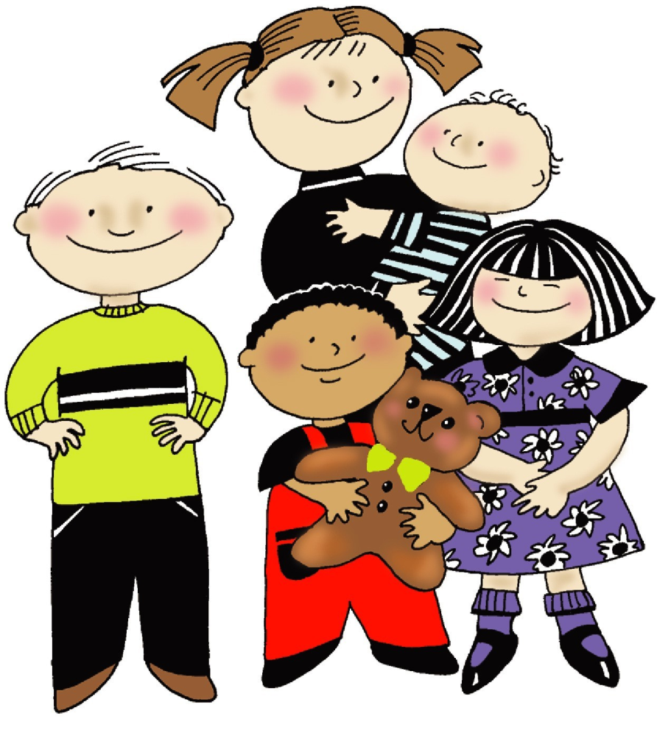
Child Care and Development

Name: ________________________ Class: _________

Child Care and Development

What is a Caregiver?
-A person who meets the many _____________ of children
-They help prevent ____________ or _______________
-They help provide an environment that fosters ________________________

Responsibilities of Caregivers
- PROVIDE A ________________ ENVIRONMENT
- PROVIDE BASIC ______________
- PROVIDE ____________________ NEEDS
- TEACH _______________ AND ______________
- DEVELOP MUTUAL ___________________
- PROVIDE APPROPRIATE ___________________
- PROVIDE AND ENCOURAGE __________________
- ____________ THEM!

Your Caregivers
*Write ONE PARAGRAPH to YOUR parents and caregivers. How have they met your needs? What have they sacrificed for you? Have they provided any “extras” for you? If they were here, what would you say to them? Will this affect how you act in the future?
_________________________________________________________________________________________________________________________________________________________________________________________________________________________________________________________________________________________________________________________________________________________________________________________________

Child Development
-Child Development: how a child becomes able to do more _____________ things as they age.
-Development is measured through specific _________________________.
-Milestones are a set of ________ or _______ that most children can do at a certain age.

Milestones
- _______________________________________
- _______________________________________
- _______________________________________
- _______________________________________
Safety for Children

Ten Tips for Safety
- Never leave a small child _____________ at any time.
- Keep the child away from _____________ equipment or ____________ objects.
- Keep _______________ closed or have a barrier across the top of stairs.
- Keep dangerous __________________ out of children’s reach
- Do not let children ____________ around with _____________ objects.
- Keep pot handles turned to the inside or ______________ of the stovetop.
- Keep children away from _______________ unless supervised constantly.
- Teach children how to ________________ their toys safely.
- Teach children to ______________ their toys when they are finished playing with them.
- Teach children to stay out of the ___________________.

NEVER EVER SHAKE A BABY!
- This could cause ______________________________________ (SBS)
- When a young child is _______________, the head whips back and forth, slamming the brain against the hard skull, causing bruising, bleeding and swelling inside the brain.
- The consequences could be __________________!

List 5 Ways to Cope with Crying
- _______________________________________________________________________
- _______________________________________________________________________
- _______________________________________________________________________
- _______________________________________________________________________
- _______________________________________________________________________

Imagination, Reading and Music

Why Are They Important?
- Fosters ____________________
- Promotes __________________ Skills
- Helps Children Become Critical _____________________
- Helps Children Practice and Apply ___________________
- Helps Promote New _____________________ and Retention (Story Telling)
- Music Increases Information _________________ (Memory!)

Toys and Playing

Why Are They Important?
- ______________ Stimulation & ________________ Solving
- Fosters _________________ & __________________
- Helps Develop ____________ Skills
- Helps Them Learn About the _______________ Around Them
- Develops ________________ Skills

Try to Remember…

Draw a picture of your favorite early childhood TOY. Describe what it was and why you enjoyed playing with it.

Describe your favorite GAME and how you played it.

Pretend Preschool Activities

Below are several simulation activities designed to help you remember what it’s like to be a preschooler. As you are doing each activity, try to imagine how a preschool feels doing tasks that we sometimes take for granted. After completing each activity, write a short reflection of how the experience made you feel.

Station 1: Small Motor Skills
Try to put a puzzle together with a blindfold on. No peeking!

Reflection:

Station 2: Math
Follow the instructions at this station to play the math game.

Reflection:

Station 3: Reading
Choose and read one of the children’s books on the table. If you get finished with one, read another.

Reflection:

Station 4: Art
Using one of the papers in the middle of the table, write a letter to your best friend using only pictures.

Reflection:

Station 5: Science
Follow the instructions at this station to complete the science experiment.

Reflection:

Station 6: Snack
Follow the instructions at this station to complete the snack activity.

Reflection:

