UNIT 1

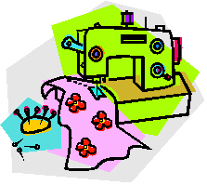Sewing

Name: ________________________ Class: _________

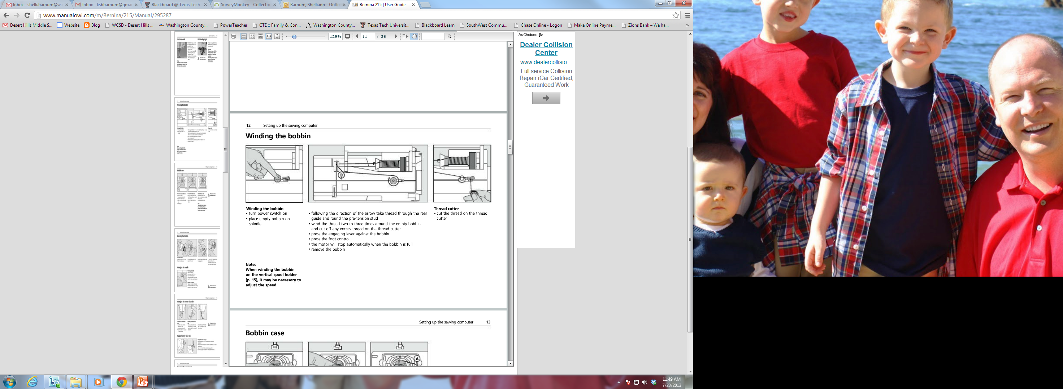

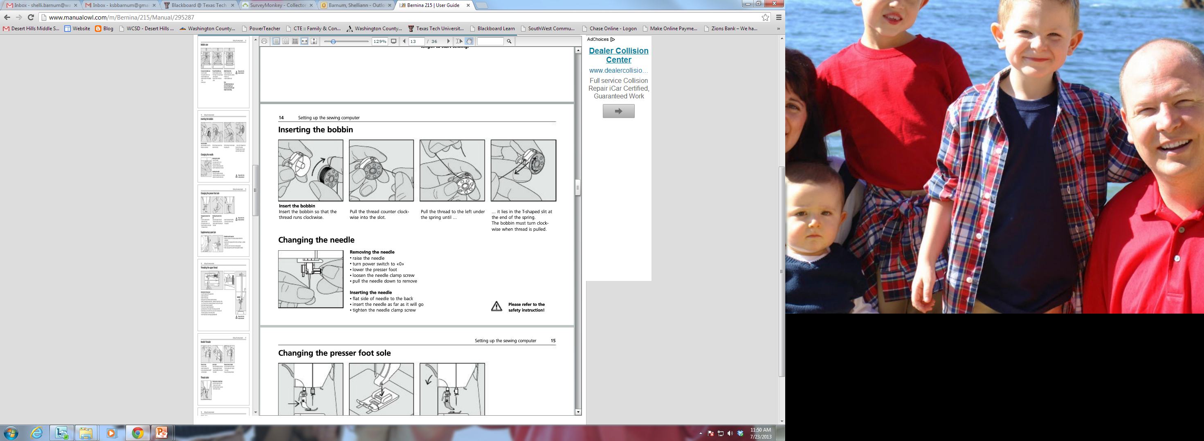

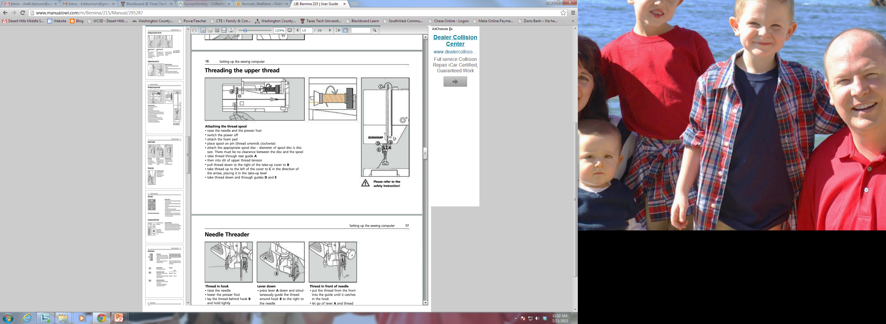

**Intro to the Sewing Machine**

|  |  |  |  |
| --- | --- | --- | --- |
| 1. | Stitch Plate | Where the seam allowance guidelines are found. (Each line is 1/8” apart.) | http://www.dognamedbanjo.com/blog/wp-content/uploads/2011/12/DSC_0154.jpg |
| 2. | Feed Dogs | Toothed metal piece below the stitch plate that moves up and down to push the fabric along beneath the needle. |  |
| 3. | Presser Foot | Holds the fabric down against the feed dogs to move the fabric evenly through the machine. | http://in.bernina.com/webautor-data/2/1008-naehfuss_klein.jpg |
| 4. | Machine Needle | The upper thread is threaded through the machine needle. |  |
| 5. | Thread Cutter | Cutting Tool on the left side of the sewing machine that allows for easy thread trimming. |  |
| 6. | Backstitch Button | When pushed in, it allows you to sew backwards until it is released. |  |
| 7. | Presser Foot Lever | Raises and lowers the presser foot. It is found on the back of the machine. |  |
| 8. | Bobbin Winder and Bobbin Stop | Winds the thread around the bobbin. | http://sewreview.com/img/gallery/714.png |

**Using the Serger**

1. Some advantages of using a serger include:
   1. **______________** off excess fabric as it sews.
   2. **______________** way of finishing a seam.
2. The three rules of serging are:
   1. **_________________________________________**
   2. **_________________________________________**
   3. **_________________________________________**
3. Do not server over **__________**, **______________** or excessive **______________.**

**Sewing Equipment**

|  |  |  |  |
| --- | --- | --- | --- |
| 1. |  | A small spool, made of plastic or metal, around which the *lower thread* of the sewing machine is wound. |  |
| 2. |  | The part of the sewing machine that holds the bobbin. | bobbin case 1 |
| 3. |  | Flexible piece of equipment used to measure body measurements, grainlines and long distances. |  |
| 4. |  | A small, slender piece of metal with a sharp point at one end and a hole, or “eye” at the other. Used for hand sewing. | https://encrypted-tbn1.gstatic.com/images?q=tbn:ANd9GcSQzEkHbUNax9KtzPdFrwvXReqcDogrT9saoQQ4DEL86RZWH313 |
| 5. |  | A small piece of equipment used to putt thread through the eye of a hand needle. |  |
| 6. |  | Small cushion used to hold and sharpen straight pins. |  |
| 7. |  | Holds layers of fabric together for cutting and sewing. |  |
| 8. |  | *Rotary Cutter*, *Cutting Mat* and *Ruler*. Equipment used to cut very straight, clean lines in fabric. Never use the rotary blade without the ruler or the cutting mat. |  |
| 9. |  | Metal 6” ruler with a sliding marker. |  |
| 10. |  | Useful sharp tool that helps to unpick small stitches. |  |
| 11. |  | Sharp cutting tool to be used only for cutting *fabric* or other fabric items. |  |

**Sewing Terms**

|  |  |  |  |
| --- | --- | --- | --- |
| 1. |  | The patterned side of fabric that will be showing when you are done sewing your project. Sometimes called the “Pretty Side”. |  |
| 2. |  | The back side of fabric that will be on the inside of the project you are sewing. Sometimes called the “Ugly Side”. |  |
| 3. |  | To machine stitch 2 or 3 stitches backwards on the same line at the beginning and end of a seam to secure the stitches. |  |
| 4. |  | Diamond shaped symbols that extend beyond the cutting line on a pattern. They are used to match up pattern pieces. |  |
| 5. |  | An arrow with bent corners to indicate pattern must be placed and cut on a folded edge of fabric. The fold itself is never cut. |  |
| 6. |  | The Stitched line that is created by sewing. |  |
| 7. |  | The distance between the edge of the fabric and the stitched lie. |
| 8. |  | The tightly woven edges on the fabric that run parallel to each other down the length of the fabric. |  |
| 9. |  | A hand stitch that is almost invisible on both the right and the wrong side of the project. |  |

