UNIT 3

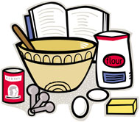
Foods and Nutrition

Name: _____________________ Class: _________

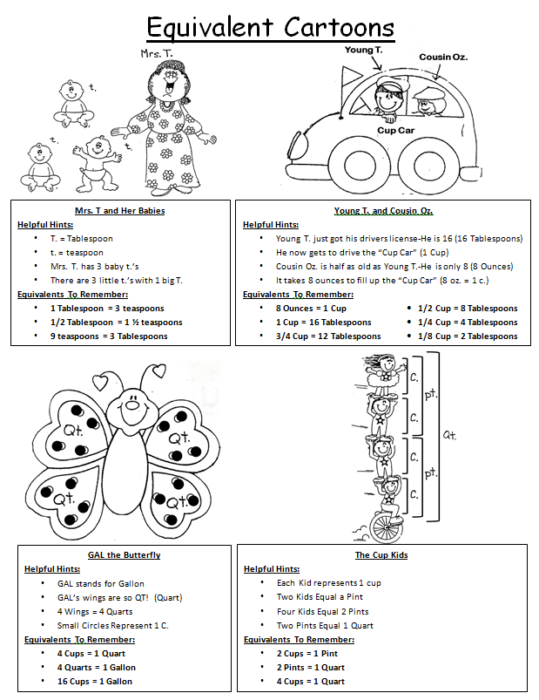
Kitchen Lab Rules
REMEMBER: BEING IN THE LAB IS A PRIVILEGE WHICH CAN BE TAKEN AWAY
- Always wear a clean apron. If your apron gets dirty in the lab, put it in the washer.
- Always tie your hair back or wear a hair net. Any loose hair must be pinned back or under a hair net until the class is over.
- Always wash your hands before touching food or equipment:
  - Use soap and hot water.
  - Wash for at least 20 seconds.
  - Use nail brush to clean under fingernails.
- Keep electrical appliances away from the water. This also includes the microwave.
- Remove hot items from the oven or microwave with hot pads or oven mitts, NOT hand towels or dish rags.
- Wash with the washing towels and dry with the drying towels. Do not use either to wash or dry your hands. Use paper towels to dry your hands after washing them.
- Never shove food down the sink drain. Always place it in the trash. There are no garbage disposals so food will rot in the drains.
- Turn pan handles toward the middle or back of the stovetop.
- DO NOT SIT ON THE COUNTERS!!! It is extremely unsanitary!
- Do NOT taste food repeatedly with the same utensil while you are preparing it.
- Stay in your OWN kitchen unit. Your group needs your help!
- Put all equipment and supplies back in the correct drawer. (All drawers and cupboards will be checked-off after each lab.)
- Clean-up your work area:
  - Wipe off counters with wet soapy dish rag and sanitizer.
  - Follow the Dishwashing Procedure listed on the board.
  - No food is to be pushed down the drain. Throw it in the garbage.
  - Wash AND dry all dishes.
  - Wash AND dry out sink completely.
  - Put dirty towels and aprons in washer. Do NOT throw them in.
- NO water fights with the kitchen faucets, or “messing around” of any kind:
  - Lab privileges will be taken away for 2 weeks.
  - All labs will be made up at home.
15. If you are absent on a cooking day, you must make the recipe at home and bring back a small sample (if appropriate) or a picture of the finished product.
Kitchen Lab Procedures & Jobs
Lab Jobs:
- You will be assigned to a lab group and given a number in that group. This number represents the “job” you will be assigned to for that cooking day. Your jobs will rotate each time you cook.
- To find your job assignment, look on the whiteboard at the front of the kitchen lab.
- If a member of the group is absent, their job must be divided among all members of the group present on that day.

Procedure for Getting Supplies:
- Any supplies needed that are not already in your kitchen unit will be collected by the group member who is assigned to that job for the day. ONLY that person should be at the supply table.
- In Cupboard 5, (under the sink), there is a pink tray. The “Supply Person” will place all measuring equipment needed on the tray and bring it up to the supply table to measure all remaining ingredients.
- After getting all supplies, take tray and all equipment back to your kitchen. Do not leave any measuring equipment at the supply table.
- Everyone should get a chance to help prepare part of the recipe. There should not be one person in charge. Share the duties and be respectful of everyone in the group.

Checkout Procedure: (Before ANYONE in your group can be excused)
- All counters must be cleaned and sanitized.
- All cupboards and drawers must be shut and closed.
- Dish soap and sanitizer must be under the sink.
- If the oven was used, all heating elements and timers should be turned off.
- If the microwave or blender was used, the inside and outside must be clean.
- All equipment must be back in the correct cupboards and drawers.
- The sink must be COMPLETY dried out, (especially around the spout and handles.)
- Make sure recipe books are clean, closed and placed on top of the microwave.

Student Signature: ___________________________________________________
Name Printed Name Date Period
Cooking Terms
1. |  | To cook by dry heat, usually in an oven. | 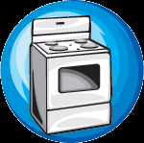
2. |  | To make a mixture smooth by lifting it over and over quickly with a big beating stroke or to incorporate air through the mixture. (Usually with an electric mixer or wire whisk.) | 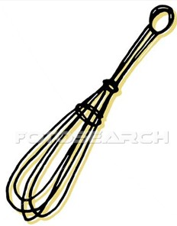  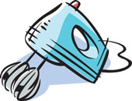
3. |  | To mix two or more ingredients together until well combined. | 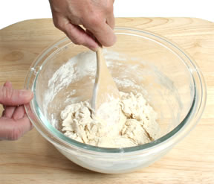
4. |  | To cook in water or other liquid in which bubbles rise continually and break on the surface. | 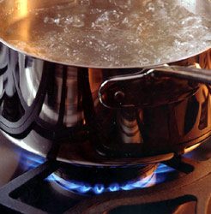
5. |  | To work sugar and fat together until the mixture is soft and fluffy. | 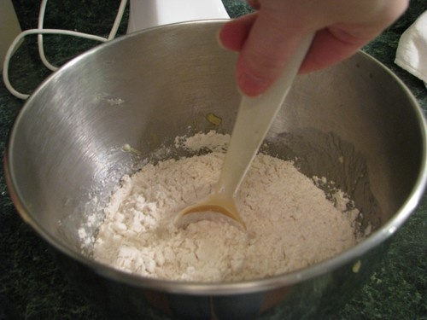
6. |  | To cut fat into flour with two knives or a pastry blender. | 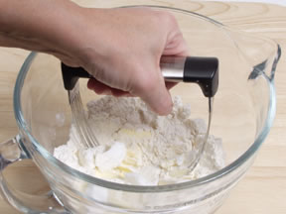
7. |  | To rub food on a surface with sharp projections. | 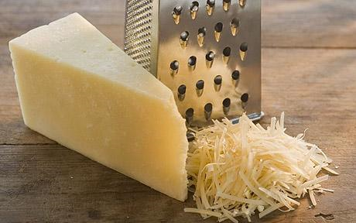
8. |  | To work dough by pressing and folding until it becomes elastic and smooth. | 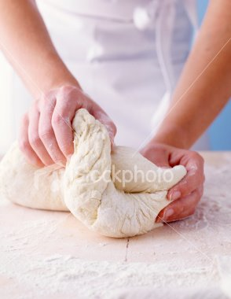
9. |  | To combine ingredients together, usually by stirring. | 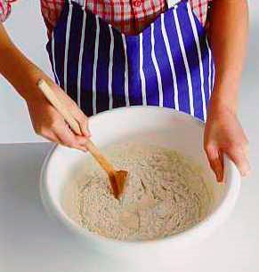
10. |  | To heat an oven prior to using in order to obtain the correct cooking temperature. | 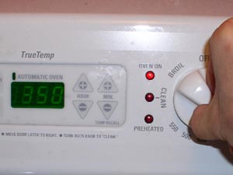
11. |  | To brown or cook food in a small amount of fat. | 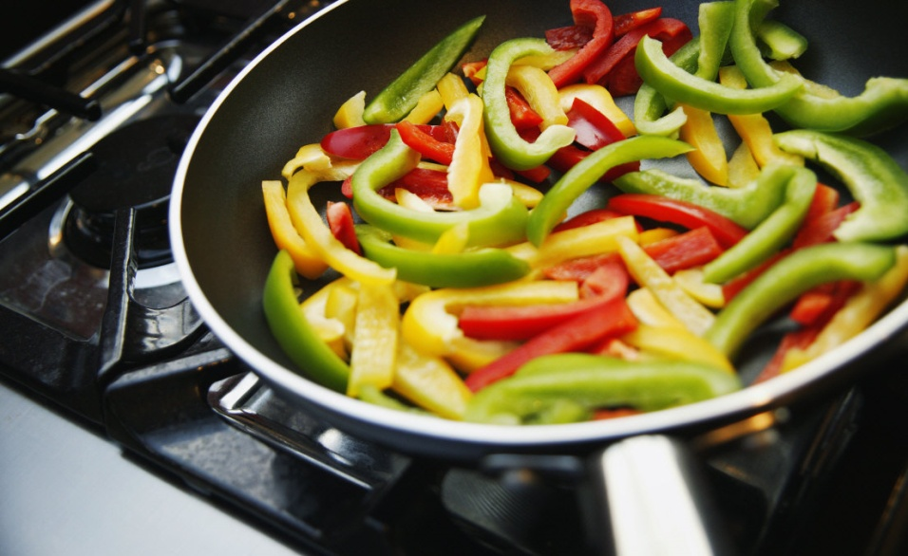
12. |  | To cook food just below the boiling point. | 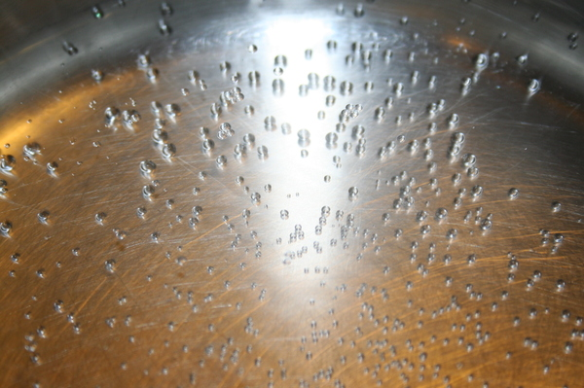
13. |  | To mix by using a circular motion, going around and around, until the food is blended together. | 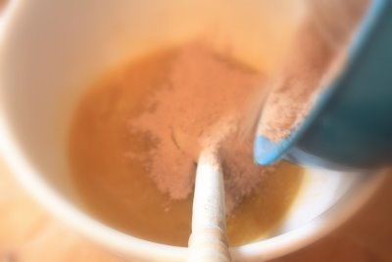
14. |  | To beat rapidly to incorporate air and to increase volume. | 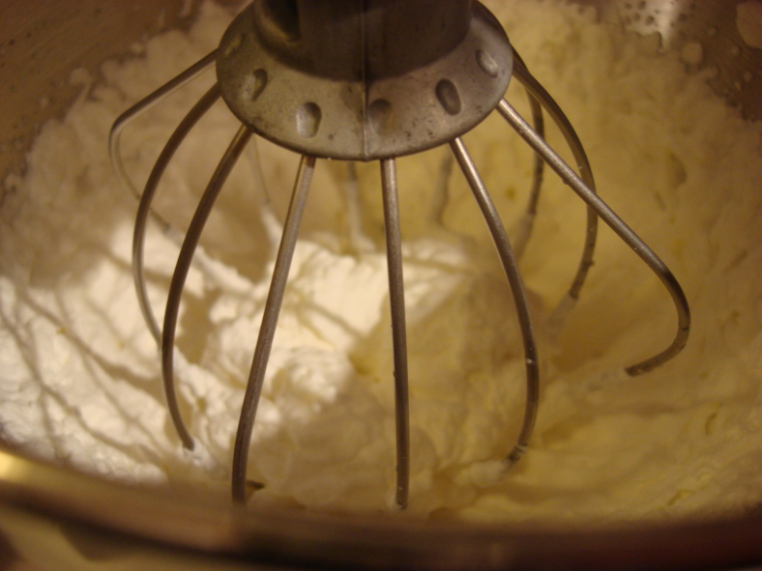

Measuring
Describe the proper way to measure each of the ingredients below:
  - Flour:
  - Sugar:
  - Brown Sugar:
  - Shortening:

  - Liquid Ingredients (Oil / Milk / Water):
  - Margarine / Butter:
  - Eggs:
The Six Basic Nutrients
- What is a Nutrient?

- The SIX Basic Essential Nutrients Are:

Nutrient | Main Function | Healthy Food Sources
 | To provide our bodies with energy | Whole grains, cereals, beans, rice, pasta
 | To build and repair body tissue | Meat, poultry, eggs, seafood, milk/milk products, cheese, nuts/seeds
 | Provides “back up energy, protects internal organs, promotes healthy skin, carries vitamins through the body | Olive oil, canola oil, avocados, olives, flaxseed, nuts, tofu, fatty fish (salmon, tuna, trout)
 | To regulate body functions (nerves, muscles and skin functions) | Fruits and vegetables (especially red, orange and dark green), enriched grains, dairy products
 | To regulate body functions (strong bones and teeth, maintaining fluid balance in the body) | Fruits and vegetables (especially red, orange and dark green), dairy products, animal products
 | Prevents dehydration, carries vitamins through the body, carries waste products out of the body, regulates body temperature | Water
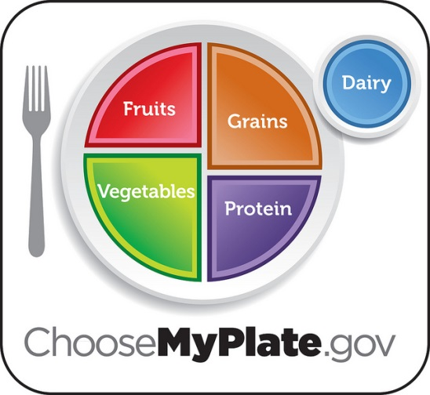
Intro to MyPlate
- What is MyPlate?

- MyPlate is broken into FIVE food groups.

Food Group | Key Consumer Message | Major Nutrients
Fruits
Vegetables
Protein
Grains
Dairy

Important Healthy Eating Tips

- _______________________________________________________________________
- Nutrient Dense: Foods that have a lot of important nutrients, but few calories.
- _______________________________________________________________________
- Empty Calories: Foods that have a lot of solid fats, sugar and calories, but few important nutrients.
- _______________________________________________________________________
- Control total calorie intake to manage body weight.
- _______________________________________________________________________
- Teens should be active at least 60 minutes or more each day.
- _______________________________________________________________________
- Spend less time in from of the TV, video games and phones and more time being physically active.
- _______________________________________________________________________
- Avoid oversized portions.

Manners and Etiquette
Code of Polite Behavior
- What is Etiquette?
- Codes of polite ________________ used in our society.
- There are different codes of etiquette all around the _______________.
- ________________ involves much more than using the correct fork when dining out.
- Using good manners/etiquette shows _______ for the people and places around you.
- Basic Social Etiquette
- Be polite ● Keep conversations polite and
- Say “Please” and “Thank You” appropriate
- Remove hats when indoors ● Be punctual
- Do not groom yourself in public ● Do not pick (nose, ears, etc.)
- Keep gum chewing to a minimum ● Do not swear
- Turn your phone ringer OFF when appropriate ● Do not stare

Basic Dining Etiquette

- Don’t talk with your mouth __________. Chew with your mouth __________.
- Don’t _________ in front of others. Ask for food to be ____________ to you.
- Don’t forget to use your _______________. Place it on your lap during the meal. Don’t tuck it into the neck of your shirt.
- Avoid __________________ or smacking your food, blowing your nose or other gross noises at the table.
- Don’t use your utensils like a ________. Take your time and enjoy your meal.
- Don’t use your __________ when dining, especially with company. Turn it off completely or at least put it on _______________.
- If your dinner party is small, ______________ until everyone has been served their meal before beginning to _____________.
- Cut large food items into _____________________ pieces. Don’t try to put the whole thing in your mouth at once. Cut only __________ piece at a time.
- Don’t prop your _________________ on the table WHILE eating.
- Say “_________________” if you need to leave the table.
Dining Styles
- There are two basic dining styles:
  - ________________________ b. ____________________________

- American Dining Style:
      - Food is cut with the _______ in the ______ hand and the ______ in the _____ hand.
      - After the food is cut, the knife is placed down and the fork ________________ to the right hand. Food is placed in the mouth with the tines facing ____________.

- European / Continental Dining Style:
- Food is cut with the _______ in the ______ hand and the ______ in the ______ hand.
- After the food is cut, the fork _______________ in the left hand and food is placed in the mouth with the tines facing ________________.

Table Settings
- Basic things to remember about table settings:
- ____________________ are placed in the order of use.
- Use utensils from the ________________ in toward the plate.
- ______________ on to the ____________ of the plate.
- ___________ and then ___________ go to the ___________ of the plate.

Label the Table Settings below:
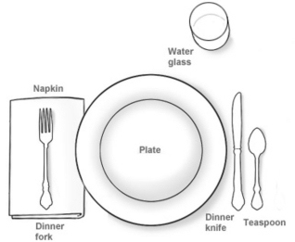 | 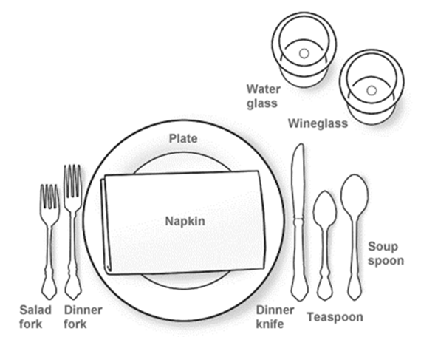 | 