Name___________________________________ Total___/ 10

Draw in walls, ceiling, floor, furniture, and accessories. Design patterns and prints for the floors, walls, window coverings and furniture. What feeling do you want this room to have?

Color Scheme_______________________________

Colors used__________________________________

Feeling you want this room to have_______________________ ________________________________________________________________________________________________

Wall

Ceiling

Floor

Furniture and accessories

Accent

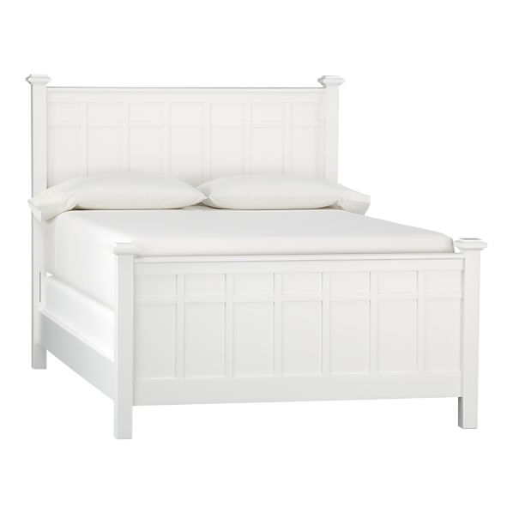

Cut here

Wall

Ceiling

Floor

Furniture and accessories

Accent

Name___________________________________ Total___/10

Draw in walls, ceiling, floor, furniture, and accessories. Design patterns and prints for the floors, walls, window coverings and furniture. What feeling do you want this room to have?

Color Scheme_________________________________

Colors used__________________________________

Feeling you want this room to have____________________ ________________________________________________________________________________________________

cut here

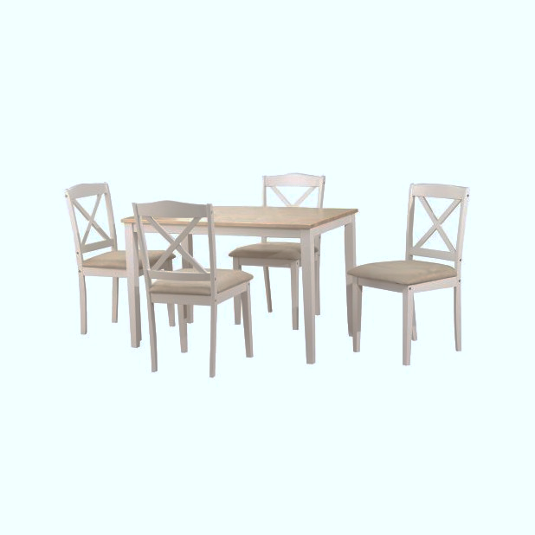

Wall

Ceiling

Floor

Furniture and accessories

Accent

Name___________________________________ Total___/10

Draw in walls, ceiling, floor, furniture, and accessories. Design patterns and prints for the floors, walls, window coverings and furniture. What feeling do you want this room to have?

Color Scheme____________________________________

Colors used______________________________________

Feeling you want this room to have______________________ _________________________________________________________________________________________________

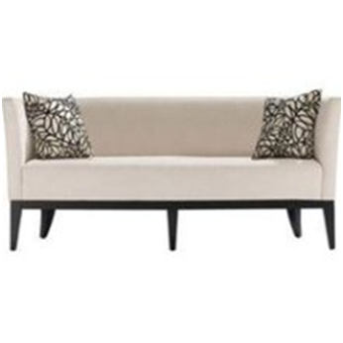

Cut here